# The logo

## Making a logo

Before starting sketching out some ideas I was thinking about the things my logo wants to show: will it be colorful, greyscale? Will it include my hobby or will it only consist of words? Etc. Well, since it will be connected to my portfolio how about making the logo with my name? maybe only the initial or with the full name.

I drew my sketches out in my notebook, so don’t mind that there are lines behind the sketches.

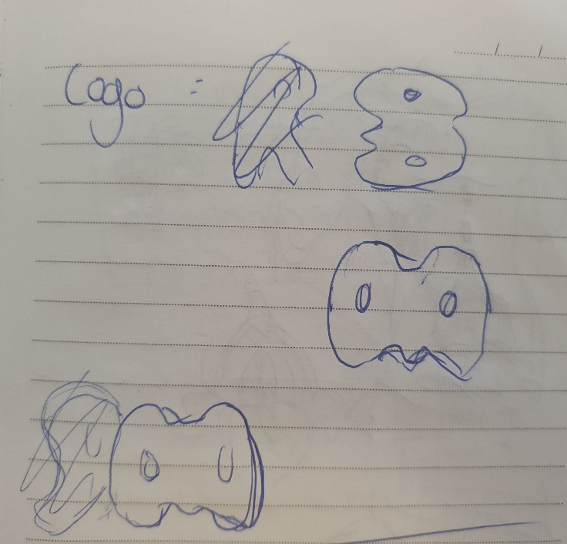

Started out with some letters: Tried to fancy the letter R but somehow the M looked funnier. So I tried to make the M fancy multiple times

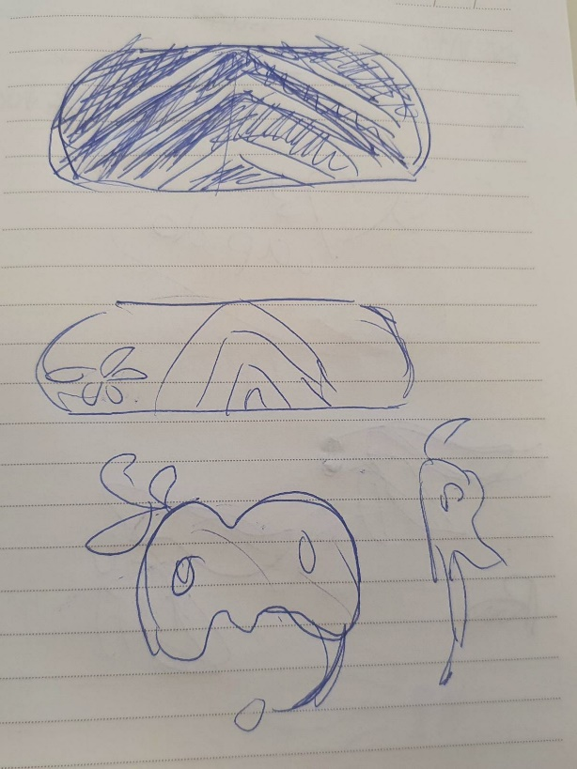

Gave up in the end since it looked too much like the Discord logo. Next to the next idea is some random cirkel and lines with flowers. Not my style and it didn’t even connect to me.

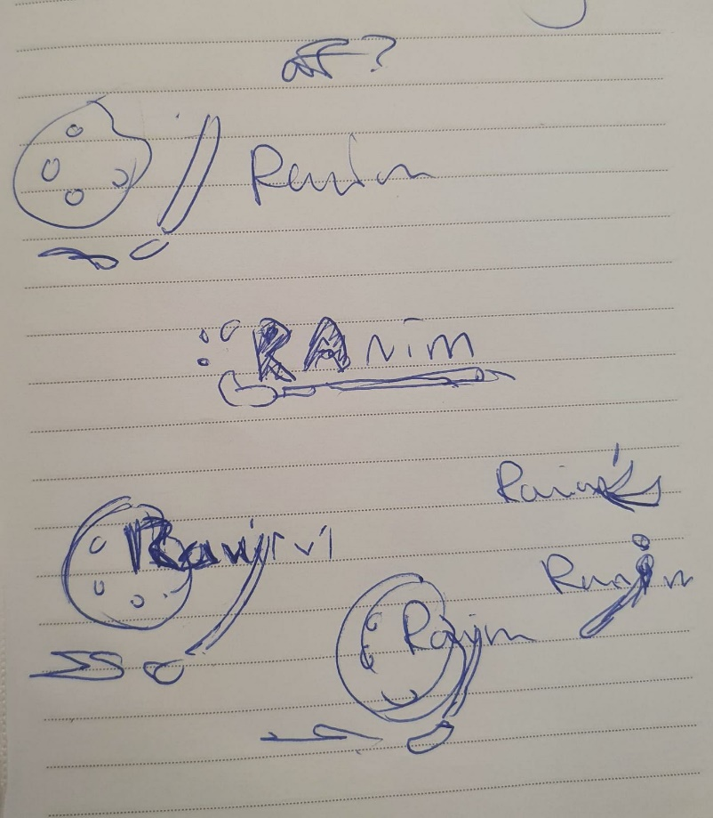

My next idea was just combining my hobby with my name. But this didn’t stick in my mind since it is not that recognizable: my idea of a logo is being simple and not too complex. So this idea is out.

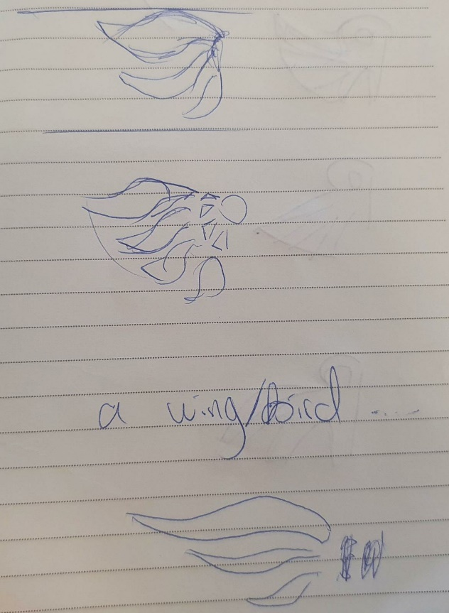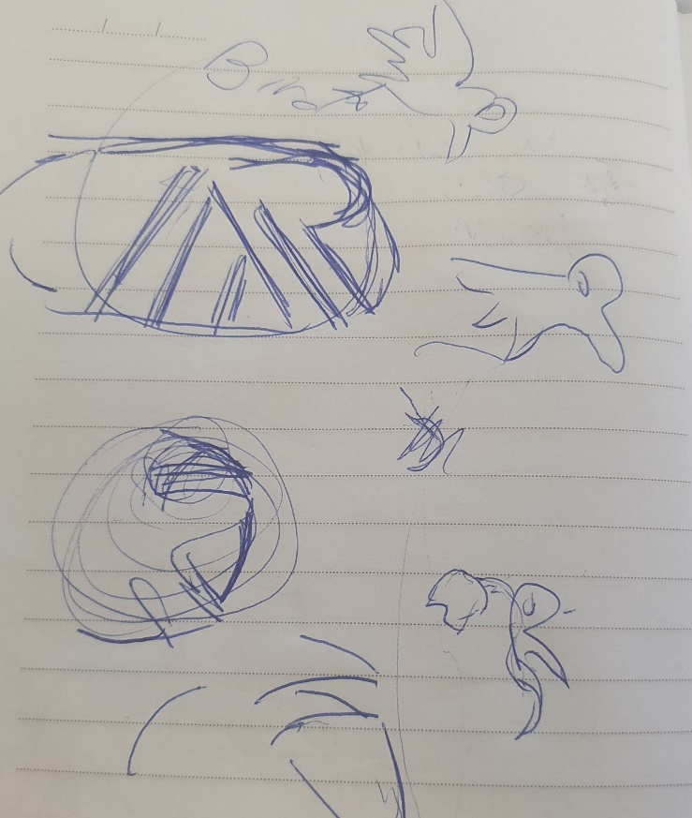

While still figuring out about the logo, I randomly saw a bird and thought: how about combining the wings to my name? After all wings symbolizes freedom, which is a perfect fit for me(freedom of thought/creativity). After multiple sketches it still didn’t fit so I tried to put the wings on the bottom instead of the side.

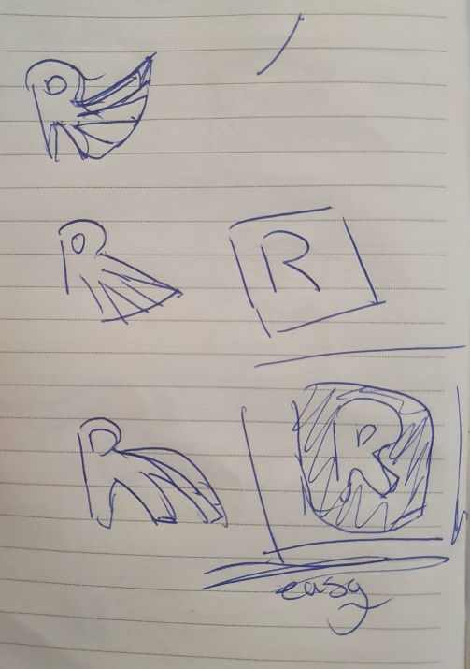

And then a sudden idea popped up in my mind: how about just making a square with my initial letter on it? For now it is black and white, however once I decided the colors on the webpage I will color them in. And that is how I got my logo.

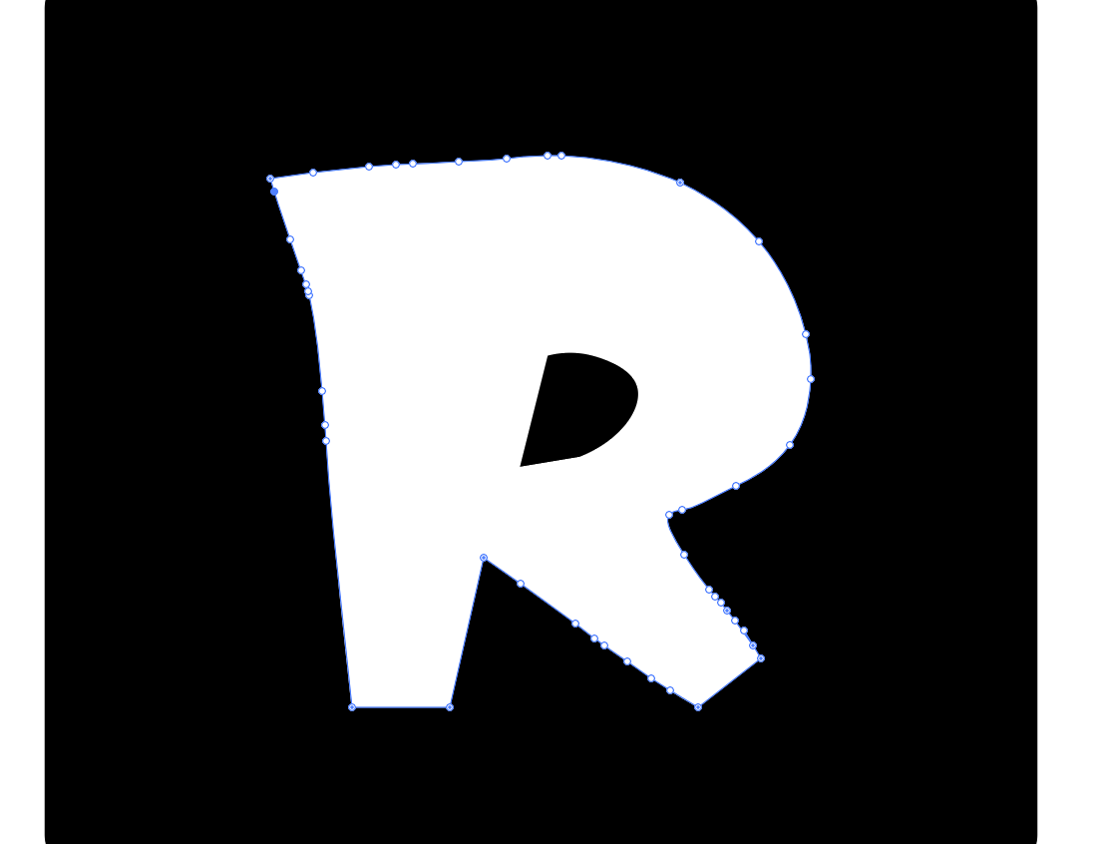

And then I made the logo in adobe illustrator. Was a lot harder than I imagined, I still cant zoom in or out. Honestly, I wanted to just draw/sketch this out and be done with it but using vectors was an interesting concept for me. So I just challenged myself.

## Mockup

